**Halveth Site Plan**

## Joshua Baird

## WDD 130



## Overview

### Purpose

To introduce and explore the exciting world of Halveth.

### Audience

All enthusiasts of fantasy and world building.



## Branding

### Website Logologo.png



## Style Guide

### Color Palette

| **Primary** | **Secondary** | **Accent 1** | **Accent 2** |
| --- | --- | --- | --- |
| #020617 | #ADBBD1 | #FFE89A | #B56FFF |

### Typography

#### Heading Font: Alegreya

#### Paragraph Font: Alegreya Sans

### Rectangle

### Navigation

Halvah Overview Tideborn Resonance



**Content**

Main page hero image and text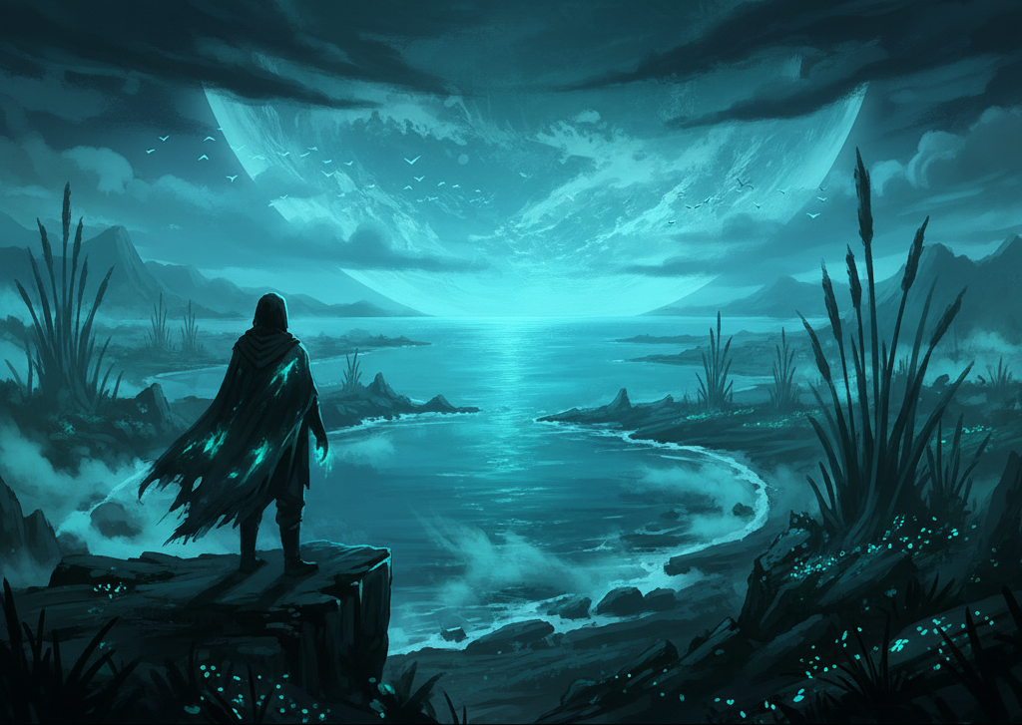

Welcome to Halveth

Welcome to Halveth, a fantasy world of perpetual twilight set on a moon that orbits a massive, glowing gas giant. There is no sun ; instead, all light comes from drifting, glowing clouds and the natural luminescence of life itself. This glow is fueled by a magical energy called Resonance: which infuses the world, is stored in water, and causes all living things, from the plants and animals to the people themselves, to glow.

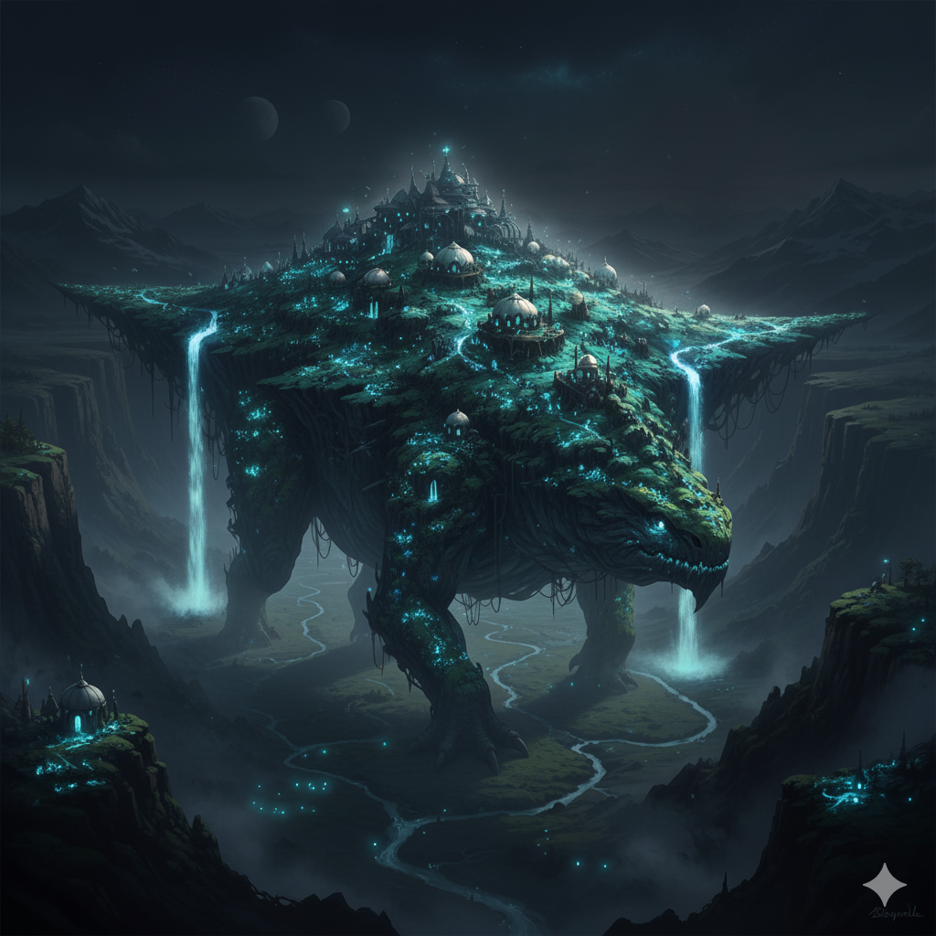

**A World in Motion**

The inhabitants of this world are the Tideborn, a nomadic people who live in cities built upon the backs of Kavethi. These are enormous, intelligent beasts that are essential for survival, providing mobility, protection, and a spiritual connection for their people. The Tideborn are in constant migration for one crucial reason: to escape the ocean. The ocean constantly moves across the moon, glowing brightly, beautiful, deadly, and filled with corruption

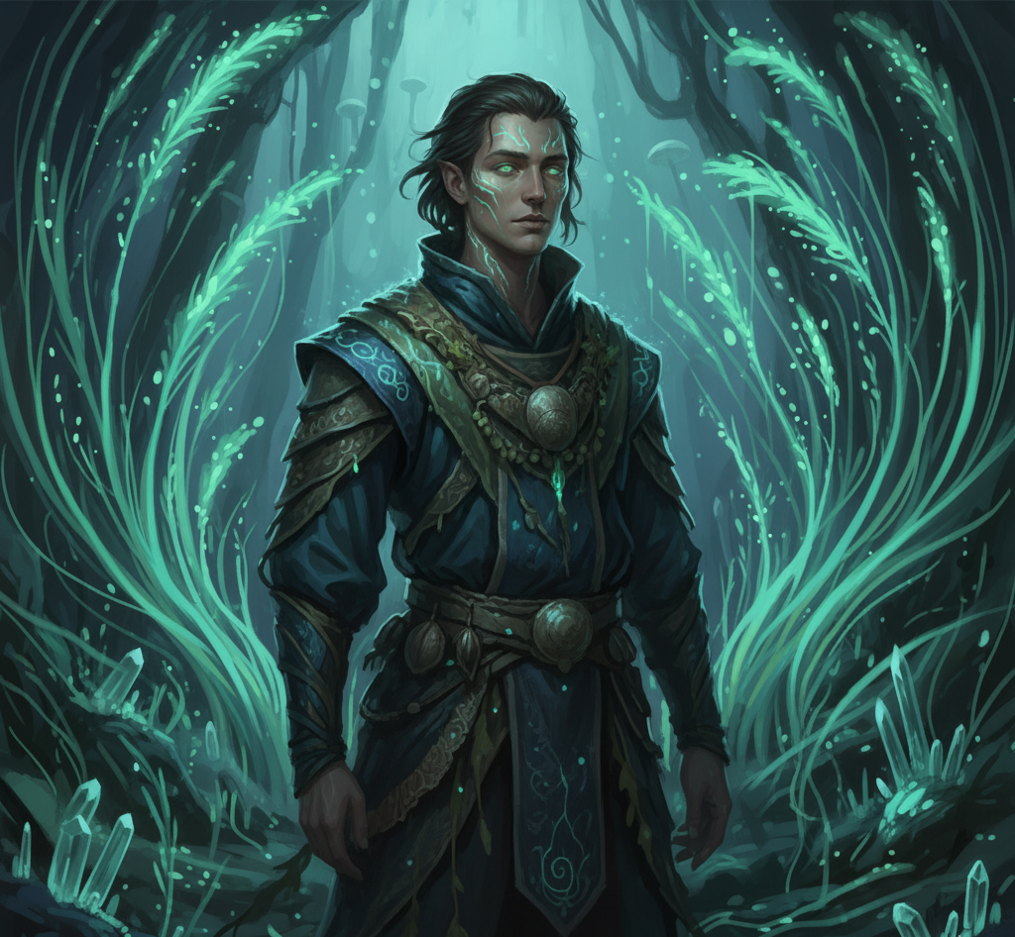

**The Duality Resonance**

The core conflict of Halveth stems from its magic. On Halveth resonance is needed to be able to survive, but for some unknown reason the use of resonance corrupts its user, slowly driving them towards madness until they reach a point of no return known as dissonance. To combat this the Tideborn form bonds with some select animals.

This corrupting energy creates monsters, most terrifyingly the Nakori—massive, violent creatures that were once Kavethi, but have lost their minds and souls to the Resonance. For the Tideborn, light is life, and the darkness is deeply feared for the threats it conceals

Page 2 or “Resonance” text

The Song of Resonance

In Halveth, magic is not spoken or read; it is performed through music and song. Every inanimate object possess a unique "soultone" or a more complex “soulsong" for living things that defines its existence. Magic on Halveth consists of using resonance to affect these soutones which will in turn affect the physical world. This process is called tuning. While Resonance is the source of all life and light, channeling it directly is perilous. it can corrupt the user and drive them toward madness. To use Resonance safely, or at least, more safely, Tideborn heroes form deep, magical bonds with specific animals or objects. These bonds allow them to channel Resonance, granting them powerful abilities and defining their role in society: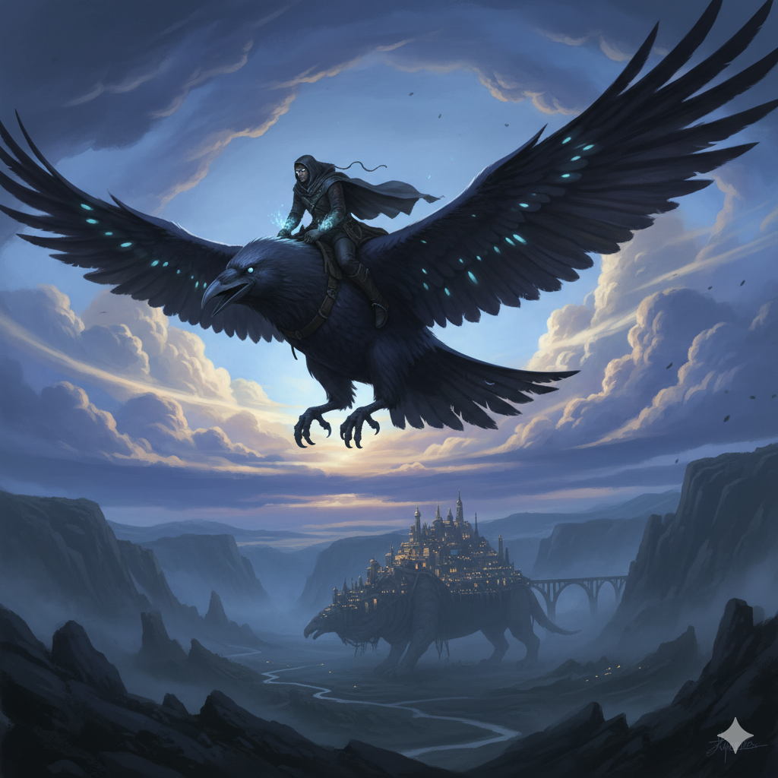

**Pathsingers**

These are the scouts of Halveth. They form bonds with one of the many giant birds. Because of the migrating ocean, One of the most common animal types on Halveth is bird. There are birds of all different sizes ranging from Stonelights, small fat stone-like birds, to a Ravenluxes, giant ravens, large enough to carry a Tideborn. An unbonded Ravenlux is dangerous because they can snatch up a Tideborn like an eagle snatches a mouse . Ravenluxes are the most common type of pathsinger bird. Once bonded, they become fiercely loyal and more intelligent. To bond a Ravenlux is no trivial task requiring dangerous retrieval of the egg of a Ravenlux. The bond grants some physical changes to the pathsinger and the ability to hear the tones of Halveth *feeling* the best path moving forward. It also grants a greater resistance to the corruption of resonance which allows some ability to tune.   
  
**Nighters**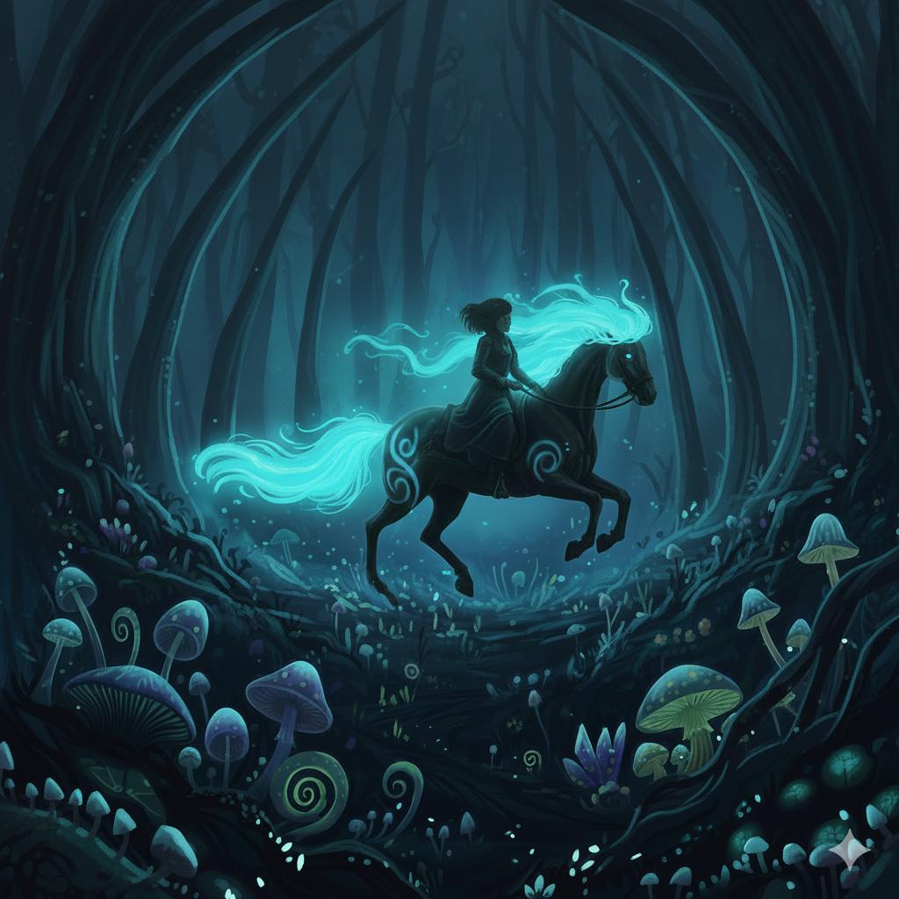

Night Riders, nicknamed the Nighters by most, are Tideborn who leave the relative safety of the Kavethi to “ride in the night” or the darkness away from kavethi. They bond beautiful glowing horses that roam the night, wild and untamed. Most of these horses are not able to be bonded, and one must usually join one of the nighter crews to bond one. The crew will wander until they find a hot spring to stay at for a short season. In order to bond, one of the horses must have a colt, which must drink from the spring, while the crew sings ritualistic songs of bonding. The prospective nighter will then bond the young colt for life. Through the bond, Nighters become gifted navigators and powerful illusionists. They specialize in hearing the “soulsongs" of people, which eventually leads to them often spotting a liar just by listening to their soulsong. Like the pathsinger bond, a nighter bond grants a greater resistance to the corruption of resonance allows for some ability to tune.   
  
**Sanari**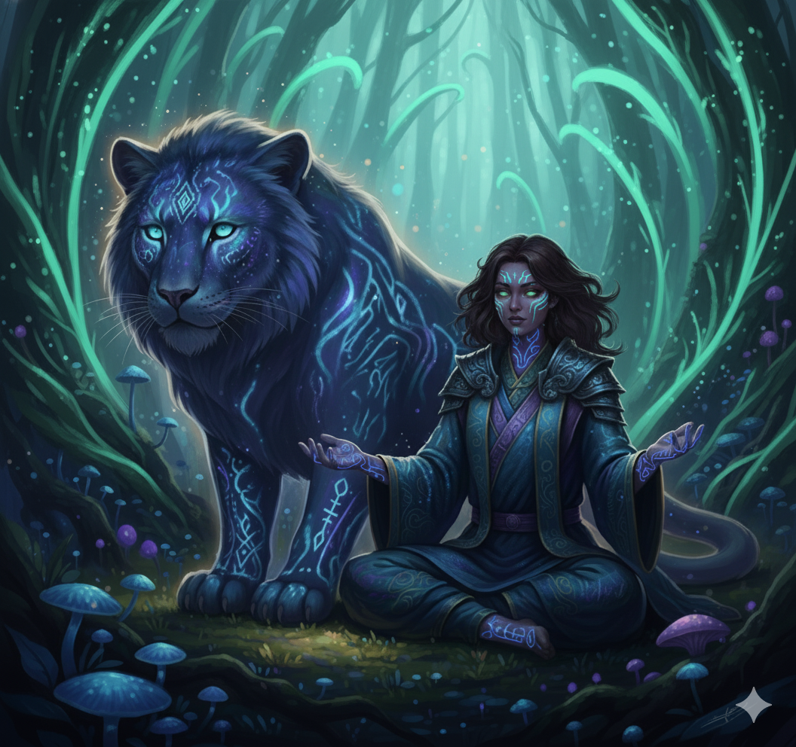

Sanari are Tideborn who form bonds with Sani, Large lion sized glowing felines. Sanari are often solitary not unlike their feline partners. There will usually only be one or 2 found on each kaveth. Once they have bonded they focus on manipulating, or tuning, soulsongs to heal and support. They heal wounds outside of battle, and will sing “battle songs of coordination” that help other Tideborn soldiers work together. The method of bonding a sanna is a closely guarded secret known only to the Sanari. On occasion a sanara will choose a favored Tideborn initiate to become their apprentice., leaving their kaveth for an extended period of time. They return with their apprentice bonded to a new Sanna. Like the bond of a pathsinger and nighter, this bond grants a greater resistance to the corruption of resonance which allows them to use resonance to tune soulsongs.   
  
**Echoblades**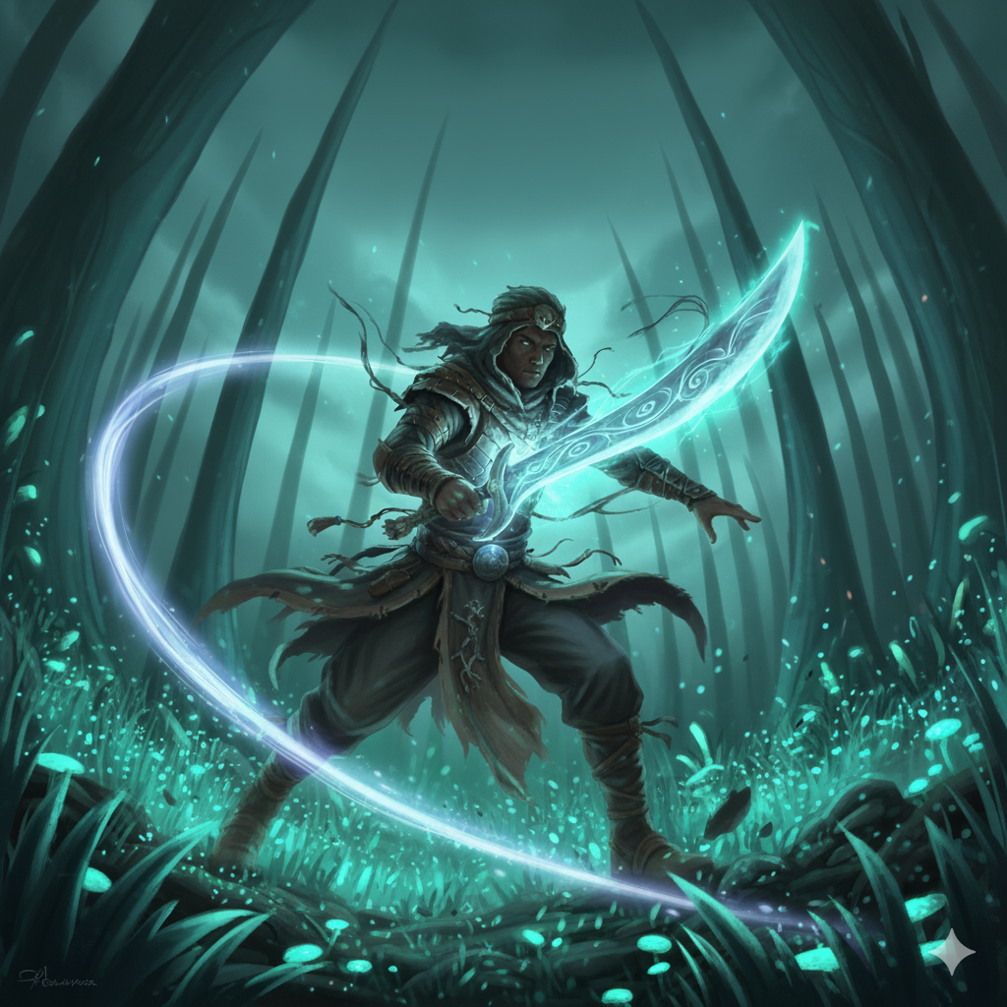

The name of both the weapon and the Tideborn, an Echoblade is a force to be reckoned with in battle. An Echoblade is a weapon forged from the rare Echostone found in the debris of volcanic eruptions. Once this is forged into a weapon, a Tideborn can form a bond with the new Echoblade. Unlike the other bonds, this bond does not change the physical appearance of the user very much. An Echoblade is most powerful where resonance is high. Their Echoblade clenses and purifies the resonance making it safe for them to channel although the process is terribly inefficient, requiring immense amounts of Resonance for them to channel. An Echoblade channels this resonance to increase their physical ability, allowing them to do super human things. In battle the shear force of an Echoblade is greatly feared.

Culture

The Tideborn, the nomadic inhabitants of Halveth, have a culture built entirely on constant motion. They live in massive cities built upon the backs of the Kavethi.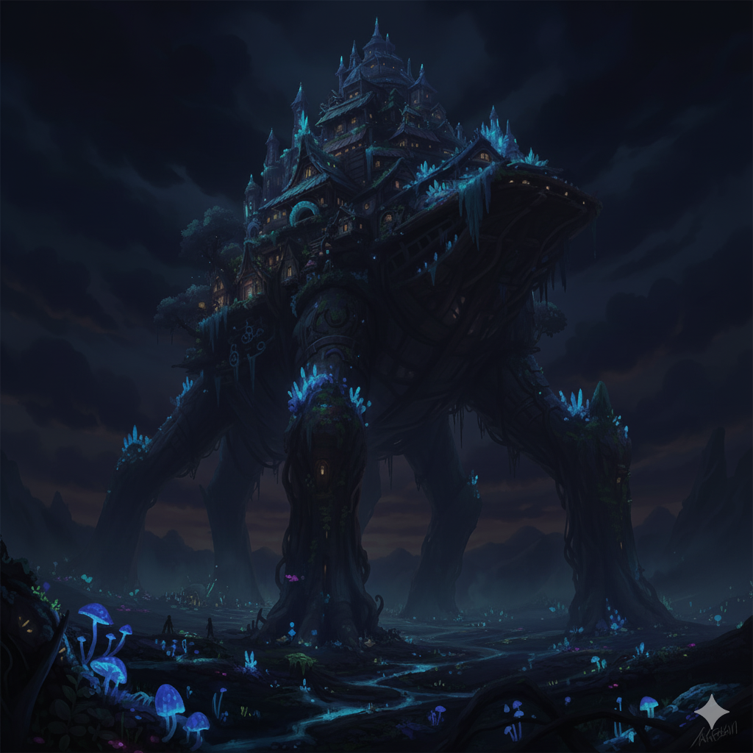

**The Kavethi**

The Kavethi are enormous, intelligent beasts fundamental to the Tideborn way of life. They are not just transportation; they are living manifestations of resonant tones, essential for mobility, protection, and a deep spiritual connection with the world. Many Tideborn worship them as Gods. Each step a Kaveth takes rings a deep **bass** chord that can be heard from afar, and simply being in their proximity helps a Tideborn battle the effects of corruption. Without tools, the Tideborn would struggle to advance; without the Kavethi, the Tideborn would surely die out.

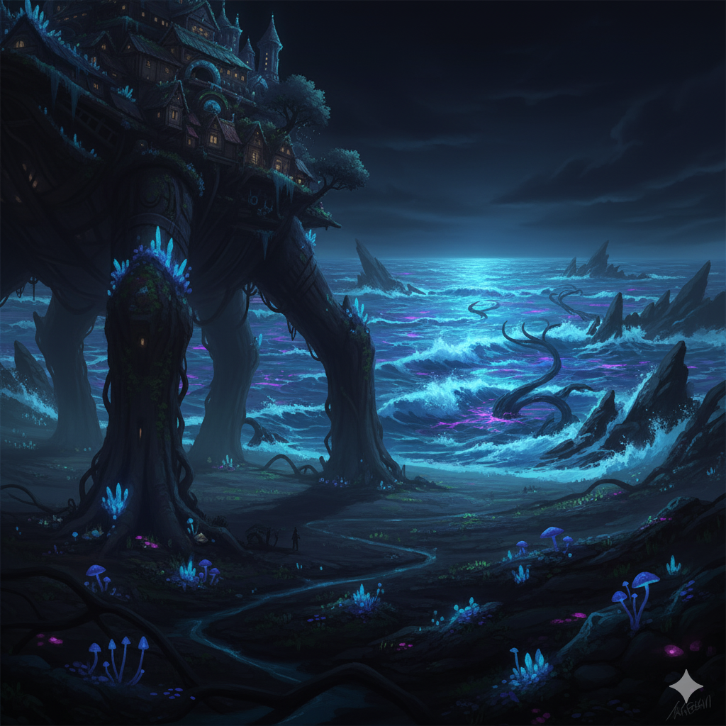

**The Great Migration**

The Tideborn are perpetually migrating away from the ocean, their lives defined by constant motion. This has led to a deeply ingrained truth: **Moving is life, stillness is death.** Tideborn songs speak of the great danger that awaits those who **lose** the strength or will to keep moving. As a result, the very idea of “settling down” is completely foreign to them. Life is a constant adventure where everything is in motion. Despite this, the Tideborn have found their own measure of stability on the backs of the Kavethi.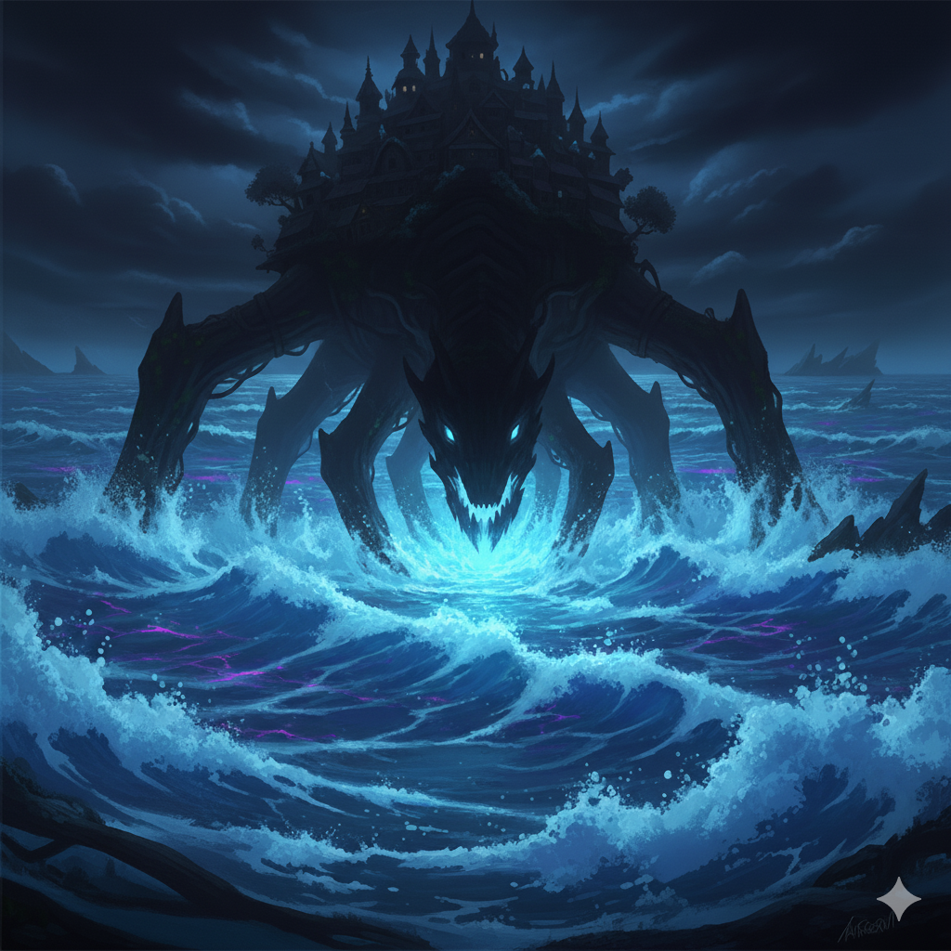

**Light Against Dark**

The ocean, while glowing and beautiful, is the world's greatest source of corruption. Anything that enters it, dead or alive, **loses** its glow, is corrupted, and is animated into a force of chaos. Most terrifyingly, Kavethi corpses left to the ocean reanimate into horrifying, leviathan-like creatures known as the Nakori. In an ocean that glows brightly with resonance, the Nakori are a chilling exception: they do not glow, appearing as the only dark shadows in the water.

This has forged a culture where light is synonymous with life and safety. The Tideborn have come to fear any part of the world that lacks a glow, as it could be hiding a corrupted being. This deep-seated fear of the dark is one of the reasons the Nighters, who ride in the darkness, are often poorly thought of.

**Wireframes**

### HomeScreenshot 2025-11-13 at 7.09.44 AM.png

### Page 2Screenshot 2025-11-12 at 5.44.46 PM.png

**Page 3**